Literature Review Summary

AI-Assisted Analysis of Student Answer Scripts
Using a CNN-LSTM Hybrid Deep Learning Model

Leclercq Simon
CESI École d’ingénieurs FISE A4 Informatique 2026 - 2027
Research Internship, Faculty of Intelligence Artificial (FAI), Universiti Teknologi Malaysia (UTM), Kuala Lumpur
September 2026 – January 2027

I – LITERRATURE REVIEW SUMMARY
1) INTRODUCTION
Higher education institutions face a persistent challenge. The evaluation of student answer scripts still relies mostly on manual grading by teachers. This process, although based on the grader's pedagogical expertise, has several limitations. It is time-consuming, especially in programs with a large number of students, and grades can vary from one grader to another on the same paper. Moreover, manual evaluation does not always capture complex learning patterns or systematically identify students who need targeted academic support.
In this context, artificial intelligence, and more specifically deep learning techniques, offer interesting perspectives to support and enrich the evaluation process. Rather than replacing human judgment, these approaches aim to provide an objective and reproducible analysis of written answers, helping teachers in their grading work and pedagogical decision-making.
Among the deep learning architectures suited for processing textual data, Convolutional Neural Networks (CNN) and Long Short-Term Memory networks (LSTM) stand out for their complementarity. CNNs excel at extracting local patterns within text, such as keyword co-occurrences, sentence structures and content markers, while LSTMs are able to model long-range sequential dependencies, such as the progression of an argument or the overall coherence of an answer. Combining them in a hybrid CNN-LSTM architecture allows to leverage both strengths in a single model.
This project takes place within a 17-week research internship at the Faculty of Artificial Intelligence (FAI) of Universiti Teknologi Malaysia (UTM), Kuala Lumpur. Its objective is to implement and evaluate a prototype hybrid CNN-LSTM model for the analysis of student answer scripts, using an existing dataset. This work aims to contribute to an ongoing research project on AI-assisted educational assessment.
2) CONVOLUTIONAL NEURAL NETWORKS (CNNs)
2.1) FUNDAMENTAL PRINCIPLES
Convolutional Neural Networks were originally developed for image recognition. They are deep learning models that automatically learn to extract useful features from data with a local structure, whether spatial (an image) or sequential (text).
The central mechanism is convolution. Small learnable filters slide over the input and compute at each position a dot product between the filter and the portion of data it covers. Each filter produces a feature map that indicates where the pattern the filter has learned to detect appears most strong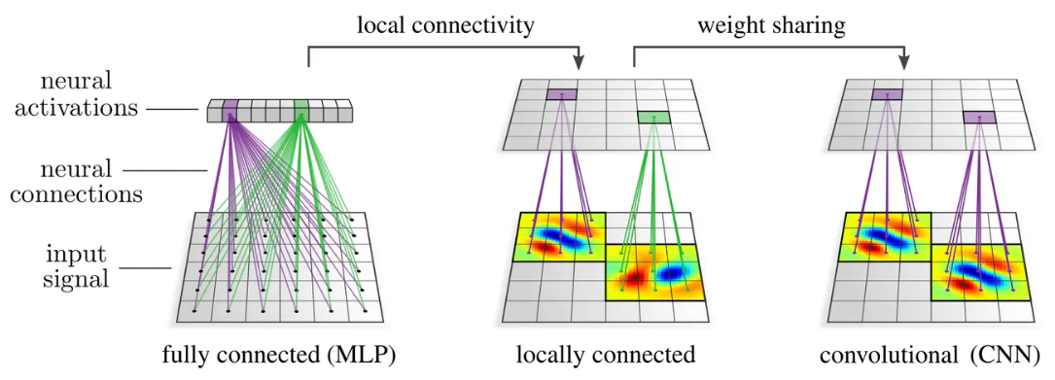
Figure adapted from Kim, Y. (2014). Convolutional Neural Networks for Sentence Classification. Proceedings of the 2014 Conference on Empirical Methods in Natural Language Processing (EMNLP), pp. 1746–1751.
2.2) WEIGHT SHARING
What makes CNNs efficient compared to classical dense networks are two properties. First, weight sharing, the same filter is reused across the entire input, which greatly reduces the number of parameters.
To illustrate the advantage of weight sharing, consider a grayscale image of 100×100 pixels. With a classical dense network, each neuron in the next layer is connected to all 10,000 pixels of the input. For a layer of 64 neurons, that gives 640,000 parameters to learn, for a single layer and on a relatively small image. And this number increases proportionally with the size of the image.
With a CNN, the cost is much lower. A 3×3 filter contains only 9 weights plus a bias, that is 10 parameters. This filter is reused across the entire image, it slides from position to position, but its parameters stay the same. With 64 filters, we get only 640 parameters, about 1,000 times fewer than the equivalent dense layer. This weight sharing is what allows CNNs to process large inputs without the number of parameters becoming unmanageable.
The same principle applies to text processing. For a 200-word student answer, a dense network would connect each word to every neuron in the next layer, also multiplying the number of parameters. A Conv1D filter of size 3 goes through the 200 words of the sequence with the same weights, detecting the same types of patterns whether they appear at the beginning, the middle or the end of the answer.
2.3) LOCAL CONNECTIVITY
Then local connectivity. Each neuron only processes a small region of the input (its receptive field) instead of looking at everything at once. These two properties allow working on large inputs without the number of parameters exploding.
Local connectivity works on the same principle. In a dense network, each neuron is connected to all 10,000 pixels of the image and makes its decision by processing all these values simultaneously, without taking into account the notion of spatial neighborhood. A neuron in a CNN, on the other hand, only processes a small local region of the input. With a 3×3 filter it only examines 9 neighboring pixels at each position. This approach is more consistent with the nature of the data. To detect a vertical edge, for example, it is enough to compare a pixel with its immediate neighbors, without needing to access a pixel located at the other end of the image.
On text, the logic is identical. To detect the presence of a technical term like "kinetic energy" in a student's answer, a Conv1D filter of size 2 only needs to examine two consecutive words. It does not need to access content located fifty words further to identify this local pattern.
2.4) APPLYING CNNs TO TEXT
CNNs were designed for 2D data like images, but they also work very well on text. Kim (2014) showed that 1D convolutions (Conv1D) applied on sequences of word embeddings captured local textual patterns and gave solid results in text classification.
In practice, the text is first converted into a matrix where each row is the embedding vector of a word. Conv1D filters go through this matrix along the sequence, looking at each position at a window of consecutive words. A filter of size 3 examines the text three words at a time and learns to detect specific combinations of adjacent words (n-grams). By using filters of different sizes (2, 3, 5 for example), the model captures patterns at multiple scales, from word pairs to longer sequences. The global max-pooling that follows selects the strongest activation for each filter across the entire sequence. In short, it answers the question "does this pattern appear somewhere in the text?", regardless of where.
This approach naturally handles texts of variable length thanks to global max-pooling, which always produces a fixed-size output.
To illustrate this mechanism, consider a student's answer to a biology question, "the cell produces energy thanks to the mitochondria". The model knows, from the training papers, that good answers often contain the words "energy" and "mitochondria" close together. A Conv1D filter of size 2 goes through the sentence two words at a time. When it hits the pair ["the", "cell"], nothing particular, weak activation. It continues, ["cell", "produces"], ["produces", "energy"], still nothing significant. But when it reaches ["the", "mitochondria"], it recognizes a marker associated with good answers and produces a strong activation. The global max-pooling then keeps only this maximum activation for that filter. The model now knows that this pattern is present somewhere in the answer, without caring about its exact position in the sentence.
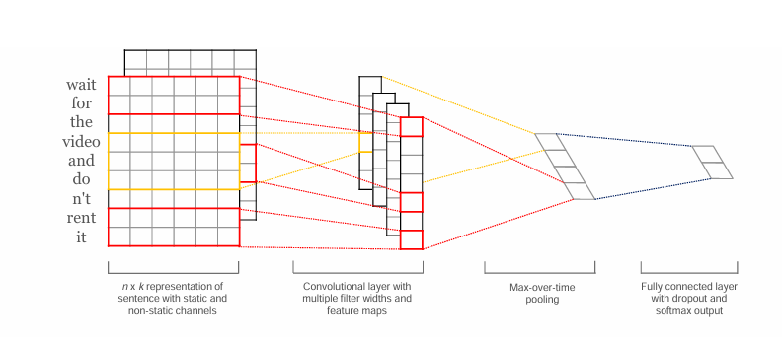
Figure adapted from LeCun, Y., Bottou, L., Bengio, Y., & Haffner, P. (1998). Gradient-Based Learning Applied to Document Recognition. Proceedings of the IEEE, 86(11), pp. 2278–2324.

2.5) RELEVANCE FOR STUDENT ANSWER ANALYSIS
For the analysis of written student answers, CNNs are well suited to detecting local linguistic features. The filters can learn to spot the presence of expected technical terms, key formulations that characterize a good answer, or conversely structures associated with incomplete or wrong answers. Several works, notably in the field of Automated Essay Scoring, have confirmed that the detection of these local markers is a strong signal for predicting the quality of an answer (Dong and Zhang, 2016).
However, CNNs have an important limitation. They only see local portions of the text. Even by stacking several layers, a CNN alone struggles to capture long-range dependencies, for example checking that the conclusion of an answer is coherent with its introduction, or that the argumentation progresses logically from one paragraph to another. This limitation is what justifies adding an LSTM after the CNN in a hybrid architecture.
3) RECURRENT NEURAL NETWORKS AND THE VANISHING GRADIENT PROBLEM
3.1) HOW RNNs WORK
Recurrent Neural Networks (RNN) are designed to process sequential data, text, time series, audio, data where order matters. Unlike CNNs which look at local windows in parallel, an RNN goes through the sequence element by element while maintaining a hidden state that summarizes what it has seen so far. At each new word, the network combines two pieces of information, the current word and the hidden state from the previous step. It then produces a new hidden state that takes into account the entire past context.
This mechanism makes RNNs suited for tasks where context is important. In the sentence "the cat eats its food because it is hungry", the RNN can in theory link "it" to "cat" by relying on the information accumulated in its hidden state throughout the reading.
3.2) THE VANISHING GRADIENT PROBLEM
During training, the Backpropagation Through Time algorithm computes the influence of each weight on the final error by going back from the last word to the first. At each time step, the gradient is multiplied by the weight matrix of the network. When the values of this matrix are less than 1, which is frequent, the gradient decreases exponentially as it goes back. After a few dozen time steps, the signal becomes so weak that it no longer contributes to updating the weights. The network loses its ability to learn long-range dependencies.
For the analysis of student answer scripts, this means that a classical RNN can correctly analyze an isolated sentence, but it will struggle to check whether the conclusion of an answer is coherent with the introduction, or whether the argumentation progresses logically across several paragraphs. This is the problem that LSTMs were designed to solve.
4) LSTM NETWORKS (Long Short-Term Memory)
4.1) CENTRAL PRINCIPLE
The LSTM architecture, proposed by Hochreiter and Schmidhuber (1997), was designed to allow recurrent networks to capture long-range dependencies without the gradient collapsing.
The central idea is the addition of a cell state, a dedicated memory channel that goes through the entire sequence with minimal transformations. It can be seen as an information highway, data can travel over long distances without being degraded. Three gate mechanisms regulate what enters, what exits and what is erased from this memory.
4.2) THE THREE GATES
The forget gate determines which part of the previous memory should be kept or erased. Based on the current word and the previous hidden state, it produces for each element of the cell state a value between 0 (erase everything) and 1 (keep everything). For example, if the text changes subject, this gate learns to erase information that is no longer relevant.
The input gate controls which new information is added to the memory. It works in two steps, a sigmoid function decides which elements to update, and a tanh function proposes candidate values. The cell state is then updated by combining what was kept by the forget gate and what is added by the input gate. This update is additive, and this is what fundamentally distinguishes the LSTM from a classical RNN. The gradient can flow over long sequences without collapsing as quickly.
The output gate determines which part of the cell state is exposed as the hidden state at this time step. It is this hidden state that is passed to the next step and, when needed, used for prediction.
4.3) VARIANTS
Two variants of the LSTM are commonly used. The GRU (Gated Recurrent Unit), proposed by Cho (2014), simplifies the architecture by merging the forget gate and the input gate into a single update gate, reducing the number of parameters while offering often comparable performance. The bidirectional LSTM processes the sequence in both directions, which is useful when the meaning of a word depends as much on what comes before it as on what comes after it, which is generally the case in text analysis.
4.4) RELEVANCE FOR STUDENT ANSWER ANALYSIS
For the analysis of written answers, LSTMs bring what CNNs cannot capture, the overall structure of the text. An LSTM can detect whether an argumentation progresses logically, whether the student has answered all parts of the question, or whether the conclusion is coherent with the elements developed earlier. These long-range dependencies are essential to evaluate the quality of an answer beyond the simple presence of keywords.
5) HYBRID CNN-LSTM ARCHITECTURE
5.1) WHY COMBINE CNN AND LSTM
As shown in the previous sections, CNN and LSTM have complementary strengths but also symmetrical limitations. CNNs are efficient at extracting local patterns (keywords, n-grams, content markers) but do not capture global dependencies. LSTMs model long-range sequential dependencies well but are slower and less effective at extracting local features.
The hybrid CNN-LSTM architecture combines both in a sequential pipeline.
First, a CNN front-end processes the input text (represented as word embeddings) and extracts local representations, the n-gram patterns, significant word combinations and structural markers.
Then, an LSTM back-end takes the sequence of features extracted by the CNN and models their temporal dependencies, how ideas follow one another, how the argumentation builds up, and whether the answer maintains its coherence over its entire length.
Finally, a dense output layer receives the LSTM output and produces the prediction (a score, a class, or any other desired evaluation).
5.2) ADVANTAGES OF THE HYBRID APPROACH
This combination has several advantages over using either model alone. The CNN reduces the length of the sequence that the LSTM has to process, which lowers the computational cost and mitigates the residual effects of the vanishing gradient. At the same time, the LSTM compensates for the purely local vision of the CNN by contextualizing its features at the scale of the entire text. Works such as Zhou (2015) have shown that this hybrid architecture outperforms CNN-only or LSTM-only models on text classification tasks, confirming the value of combining local extraction and sequential modeling.
6) APPLICATIONS IN EDUCATIONAL NLP
6.1) AUTOMATED ESSAY SCORING (AES)
The field where the CNN-LSTM architecture is most directly applicable to this project is Automated Essay Scoring. AES consists of automatically assigning a score to a text written by a student, based on features learned from examples annotated by human graders.
Traditional AES approaches relied on manually designed features, text length, number of spelling mistakes, syntactic complexity, vocabulary richness. These methods, although functional, required significant engineering work and were hard to generalize from one type of question to another (Dong and Zhang, 2016).
Deep learning approaches changed the game. Taghipour and Ng (2016) were among the first to apply CNN and RNN architectures to AES, showing that deep learning models could reach performance close to that of human graders on standardized datasets. Dong and Zhang (2016) then showed that a hierarchical CNN, processing first words at the sentence level, then sentences at the essay level, could automatically extract relevant features without manual engineering.
6.2) QUALITATIVE ANALYSIS
The analysis of student answer scripts is not limited to assigning a score. It can also be used to identify recurring patterns of understanding or misunderstanding, to spot students in difficulty who need targeted support, or to provide qualitative feedback on the strengths and weaknesses of an answer. These finer objectives require a richer analysis than simple regression toward a score, and justify the use of architectures capable of capturing both the local content and the overall structure of an answer, which is what the hybrid CNN-LSTM model can provide.
7) TEXT REPRESENTATION AND PREPROCESSING
7.1) TOKENIZATION
Before any processing by a deep learning model, raw text must be converted into a numerical representation. The first step is tokenization. The text is split into processable units (tokens), which can be whole words, subwords or characters depending on the chosen method. For the analysis of student answer scripts, word-level tokenization is the most common. Subword tokenization can help better handle rare or misspelled words.
7.2) WORD EMBEDDINGS
Each token is then converted into a dense vector (a list of numbers) through an embedding. Two approaches are possible. Pre-trained embeddings like Word2Vec (Mikolo, 2013) or GloVe (Pennington, 2014) provide vector representations learned on large general-purpose text corpora, where words with similar meanings have close vectors in the space. Contextual embeddings, from models like BERT (Devlin, 2019), go further by producing representations that vary depending on the context in which the word is used. The word "bank" will not have the same vector in "river bank" and "bank account".
The choice of embedding method can have a significant impact on the model's performance, especially in an educational context where student vocabulary can include technical jargon, informal language or very varied levels of syntactic complexity.

7.3) STANDARD PREPROCESSING
The typical preprocessing steps include lowercasing, stop word removal (with caution, as some words like "not" carry important meaning in a student answer), and padding or truncating sequences to a uniform length to allow batch processing. The quality of preprocessing has a direct impact on the model's performance and must be adapted to the specificities of the dataset used.
8) LIMITATIONS OF THE EXISTING LITERATURE
The literature review highlights several observations. First, the majority of AES works have been conducted on long and standardized essays, mainly in English and in the context of language proficiency tests (TOEFL, ASAP dataset). The application of these models to short or technical answers, typical of university exams in scientific or technical disciplines, remains largely unexplored.
Second, most existing systems focus on assigning a global score, without providing a detailed analysis of the strengths and weaknesses of the answer. Yet the pedagogical value of such a tool lies as much in the diagnosis as in the grade itself.
Finally, hybrid CNN-LSTM architectures, although promising in text classification, have been rarely evaluated specifically on student answer analysis tasks, especially on modest-sized datasets, which is often the case in universities.

9) RESOURCES USED
9.1) REFERENCES
Kim, Y. (2014). Convolutional Neural Networks for Sentence Classification. Proceedings of the 2014 Conference on Empirical Methods in Natural Language Processing (EMNLP), pp. 1746–1751. https://arxiv.org/pdf/1408.5882.pdf
Hochreiter, S., & Schmidhuber, J. (1997). Long Short-Term Memory. Neural Computation, 9(8), pp. 1735–1780. https://www.bioinf.jku.at/publications/older/2604.pdf
Zhou, C., Sun, C., Liu, Z., & Lau, F.C.M. (2015). A C-LSTM Neural Network for Text Classification. arXiv preprint arXiv:1511.08630. https://arxiv.org/pdf/1511.08630.pdf
Taghipour, K., & Ng, H.T. (2016). A Neural Approach to Automated Essay Scoring. Proceedings of the 2016 Conference on Empirical Methods in Natural Language Processing (EMNLP), pp. 1882–1891. https://aclanthology.org/D16-1193.pdf
Dong, F., & Zhang, Y. (2016). Automatic Features for Essay Scoring, An Empirical Study. Proceedings of the 2016 Conference on Empirical Methods in Natural Language Processing (EMNLP), pp. 1072–1077. https://aclanthology.org/D16-1115.pdf
Devlin, J., Chang, M.-W., Lee, K., & Toutanova, K. (2019). BERT: Pre-training of Deep Bidirectional Transformers for Language Understanding. Proceedings of the 2019 Conference of the North American Chapter of the Association for Computational Linguistics (NAACL-HLT), pp. 4171–4186. https://arxiv.org/pdf/1810.04805.pdf

9.2) ADDITIONAL RESOURCES
Science4All. Les réseaux de convolution (CNN) | Intelligence artificielle 47. Introduction to CNNs, convolution and pooling. https://www.youtube.com/watch?v=zG_5OtgxfAg
CNRS - Formation FIDLE. CNN1/ Réseaux convolutifs (CNN). Structured course on CNN fundamentals. https://www.youtube.com/watch?v=581X9wsnWJs
CNRS - Formation FIDLE. CNN2/ Classification basique via un CNN (MNIST). CNN implementation on the MNIST dataset. https://www.youtube.com/watch?v=zPwQiZFrwUY
CNRS - Formation FIDLE. CNN3/ Exemple avancé : GTSRB (1/2). CNN application on a road sign dataset. https://www.youtube.com/watch?v=IIxbNn2ucG0
CNRS - Formation FIDLE. CNN4/ Exemple avancé : GTSRB (2/2). Continuation of the CNN implementation on GTSRB. https://www.youtube.com/watch?v=33iW7Y3uuOw
Weights & Biases. 8. Text Classification Using Convolutional Neural Networks. Applying CNNs to text classification. https://www.youtube.com/watch?v=8YsZXTpFRO0
3Blue1Brown. L'attention dans les transformers, expliquée visuellement | Chapitre 6, Apprentissage profond. Visual explanation of the attention mechanism. https://www.youtube.com/watch?v=eMlx5fFNoYc
Thibault Neveu. Comprendre les LSTM - Réseaux de neurones récurrents. Explanation of LSTMs, gates and cell state. https://www.youtube.com/watch?v=3xgYxrNyE54

